VEN SPRAY SMART LINE
Capacity & Drying time:
Capacity C= 700m²/shift : 480min/shift = 1,458m²/min
Line speed: v= 1,5m/min
Drying time:; t= 6 x 5,5m : 1,5m/min = 22 min (temperature 35-40°C)

Pos. |  | Description
Pos. 1 | 1 x | VEN TRANS BELT – BATCH LOADING CONVEYOR
Pos. 2 | 1 x | VEN CLEAN ONE
Pos. 3 | 1 x | VEN SPRAY SMART - SPRAY MACHINE
 | 1 x | Conveyor Belt Scraper and Cleaning System R1
Pos. 4 | 1 x | VEN DRY COLLECT LL - 6-LEVEL DRYER
Pos. 5 | 1 x | VEN TRANS ROLLER - ROLLER CONVEYOR
Pos. 6 | 1 x | VEN CONTROL SWITCH - CONTROL CABINET

Line parameters:

Operating width | 1.300 mm
Production speed | 1,5 m/min
Speed range | 1,5-4,5 m/min.
Operating level | 920+-20 mm
Components to be finished | furniture elements
Panel size | L x W x H
min. | 300 x 100 x 10 mm
max. | 2.600 x 1.300 x 50 mm
Spray materials | solvent based lacquer or water based lacquer
Supply voltage | 230/400 V 50 Hz TNC
Voltage fluctuation max. | +/- 5%
Control voltage | 24 V
Ambient air temperature | 18 - 35°C
Height over sea level max. | 1.000 m
Machine colour
Spray Machine | Grey RAL 7035
Conveyors | Grey RAL 7035
Design details | Black RAL 9005
Control cabinet | Grey RAL 7035
Operating side of the line | hand side
Heating medium for the drying tunnels | hot water 90 / 70°C
Exhaust air volume approx. | 15000m³/h
Electric power supply approx. | 40 KW
3/400V TNC | 67A
Heating power consumption ca. | 80 kW

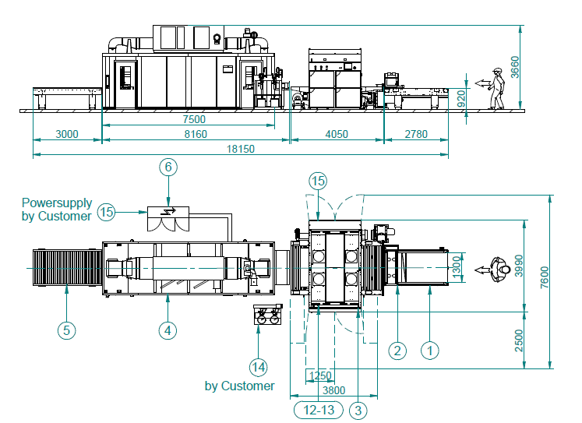
The plant consists of the following items:

22-10003-EN

VEN TRANS BELT – BATCH FEEDING CONVEYOR
The frame of the unit is made in a robust bolted profile steel construction. The side elements are of profiled sheet steel in closed execution.
Build with a closed belt conveyor surface.
The conveyor is build to create the needed batch length to feed the batch length related drying oven. A batch length/gap related gap mark on the surface of the belt conveyor supports the operators loading activities.
The drive is effected by a geared motor prepared for inverter speed variator.
Unit without electric control elements.

Technical data:
length: 2.780 mm with gap mark
operating width: 1.300 mm
outside width: 1.706 mm
motor power: 0,55 kW

TB-14-20400

VEN CLEAN ONE – DUST CLEANING DEVICE
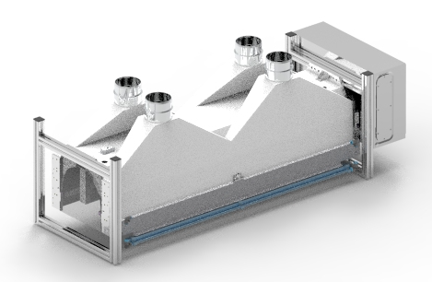
The dust cleaning device is used for removing dust from the profiled panel surface by compressed air.
5 Rotating blowers are lifting the dust from the panel. The dust is extracted into hood and sucked to the central dust extraction.
The parts are conveyed on a conveyor section.

Technical data
Dimensions: 600 x 1.750 x 660mm (L x B x H)
Operating width: 1.300 mm
Part height: 50mm
Provided by the customer:
Exhaust air volume required : 4.000 m³/h
Compressed air consumption : 1.800 Nl/min., 6 bar
Control voltage: 24 V

10-11000-EN

VEN SPRAY SMART - SPRAY MACHINE
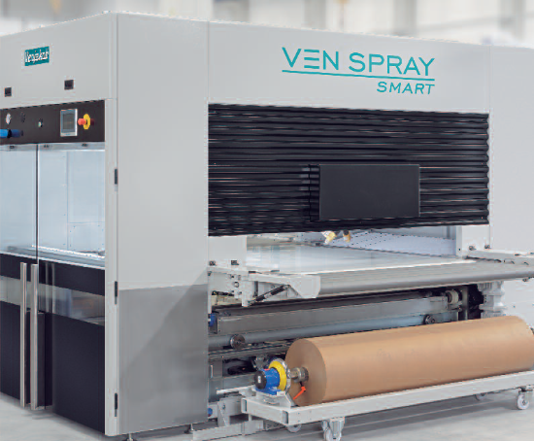
The unit comprises:

1 Spray Cabin
The cabin housing is made of a sturdy sheet steel construction. Large glass folding doors are situated on the operating side of the machine for easy access and visual control of the lacquering process. Fluorescent lighting illuminates the spraying area. Additional inspection doors are fitted at the rear of the machine. The doors are fitted with safety switches.
An operating panel with all relevant controls and gauges is mounted above the folding doors.

The operating panel touch screen surface can be switched from Romanian to Russian language.

1 Spray Gun Drive System “Z 10“
A strengthened high-performance linear drive unit mounted in the centre of the spray machine. The linear unit is fully enclosed and integrated in the supply air roof to prevent damage due to ingress of paint spray or dirt. The running unit (spray gun carrier) is constructed of warp-resistant alloy with heavy duty roller bearing running wheels and is driven by a toothed belt. This construction ensures a uniform spray gun speed across the entire working width. Spray gun speed is infinitely adjustable from 0,4 – 2,0 m/sec (Max. 25 double strokes / minute). The acceleration and deceleration of the gun drive is automatically adjusted according to the speed, giving a smooth spray gun movement. The unit drive is a servo motor.

1 Gun carrier arm
The gun carrier arm is fitted with all fixing materials for 4 guns and height adjustable. The spray guns angle is individually adjustable.

1 Exhaust System “DRY 7000”
Constructed of galvanised steel,
Consisting of:
2 extraction chambers are mounted on each side of the transport belt. Each chamber is fitted with primary paper filters and secondary fibre filters, both are easily removable. The extraction chambers are connected to the main exhaust chamber under the transport belt.
1 Free-Standing Exhaust Ventilator
Exhaust Volume; 7.000 m³/h (approx. 4.120 cfm)

1 Parts recognition
For the automatic control of the spray guns. The control recognises the loading width of the work pieces and activates the individual spray guns accordingly. Control and operation of the machine is made via Touch Display installed at the operating panel of the machine. Numerous spray programs can be set and stored for future use in the control unit.

1 Electrical Control Cabinet
Included in the spraying machine. It is equipped with all necessary switch and safety elements, motor protection units, control lamps and main switch. The unit is cooled by axial fans. All components are connected to terminal clamps.

1 Filtered Air Supply Roof AV
fully integrated in the upper cabin. The filtered air is directed downwards over the spray area to the extraction chambers. Filters are easy to remove.
Unit consists of:
4 Axial Supply Ventilators with adjustable air flow
2 Stage Filtration, Filter class G4 / F3

1 Conveyor Belt System
This allows operation of the machine with a “Paper Conveyor” or with a “Scraper and belt cleaning system”. The unit consists of:
1 In feed roller section
1 Endless conveyor belt, sealed surface and solvent resistant with pneumatic tracking
1 Out feed roller section
The conveyor drive is via frequency converter

1 Paint Supply Circuit NW 6
For the supply of 4 spray guns. Executed as a ring rinsing circuit for quick colour changes. Including rinsing valve, 4 spray gun mounts, solenoid valves, fixing material and air lines.

10-11200-EN

Conveyor Belt Scraper and Cleaning System R1
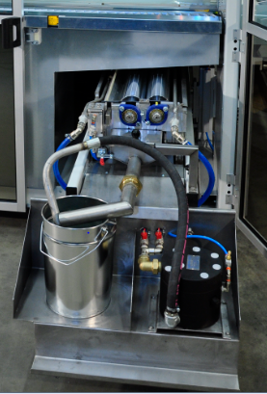
With lacquer recovery/reclaim system of the oversprayed lacquer. The unit consists of:
1 Scraper reclaim system, with an oscillating scraper mounted transverse to conveyor direction.
1 Conveyor belt cleaning system with 2 cleaning rollers, fluid supply pump and reservoir for flooding of the cleaning rollers.
The complete unit can be removed to the operating side for cleaning and maintenance purposes.

30-5010-EN

VEN DRY COLLECT LL - 6-LEVEL DRYER
the unit is designed for efficient flashing off of components in lengthwise
air flow. The unit comprises:

6 belt pallets
with guided conveyor belts for feeding through the unit.

1 Drive unit for the belt pallets
inverter controlled for adjusting the speed.

1 Lifting gear for lifting and lowering process
the belt pallets are vertically guided and carried ba 4 chains with counter weight driven by two geared motors with inverters.

1 Dryer housing
made of insulated sandwich panels. The in and outfeed do have windows for inspection. For maintenance the panels are individually removable
For feeding and discharge two roller conveyors bridge the gap between the before standing and following conveyors.

1 Ventilation system
the in and outblow units are fixed to the infeed and outfeed area of the six belt conveyors and do allow a most efficient end even flash off process.
1 Air ventilation and heating unit
positioned on top of the dryer housing with heat exchanger and radial fan witth adjusting flaps and 2 stage air filtering unit.
1 electric temperature control device as loose items.

1 Control Cabinet
with all control elements and relays. The control is effected by the PC-Control system of the spray machine.

The oven is prepared for a drive through mode of h= 100 mm workpieces by running through on top palet 6 in operating height 920mm.

Technical Data:
Length: 7.504 mm
Width: 2.300 mm
batch length: 5.500 mm
Total height: 3.585 mm
Operating width: 1.300 mm
Light opening height: 73 mm
Max. object hight: 60 mm
Top level palet: 100 mm
Air temperature: 40°C
air speed between pallets: 0,5 m/min.
Heating medium: hot water PWW
Exhaust air volume 3.000 m³/h
Heating consumption +15/40°C:80 kW
22-10003-EN

VEN TRANS ROLLER - ROLLER CONVEYOR
The frame of the unit is made in a robust bolted profile steel construction. The side elements are of profiled sheet steel in closed execution. Each roller is fitted with two heavy duty bearings.
The rollers are fitted with shrunk on protection hases and driven by a maintenance free chain system.
The drive is effected by a geared motor prepared for inverter speed variator.
Unit without electric control elements.

Technical data:
length: 3.000 mm
operating width: 1.300 mm
roller ø: 80 mm
roller pitch: 200 mm
outside width: 1.706 mm
rolletube ø: 25 mm
motor power: 0,55 kW
40-10000-EN

VEN CONTROL SWITCH - CONTROL CABINET
As additional item beside the line to provide the needed inverters and electrical switches to the complete the whole line functionalities from Pos. 1 to Pos. 4.
For all quoted items, with all necessary control and protection elements, motor relays indicators, displays and main switch. All elements are internally pre wired on marked series clamps.
The cabinet includes all free contacts for interlocking our and also machines of other suppliers. (not explosion proof design)

Total connecting el. Power supply: 40kW

