
SEPROTEQ Sàrl
Engineering & Solutions for Bottling and Packaging
Route Suisse, 8A - CH – 1163 ETOY – SWITZERLAND
Numéro fédéral : CH-660.0.782.006-7 IDE: CHE-112.848.256

ATLANTA
Wrap-around packing machine
Giotto
premium 2nd hand year 2015

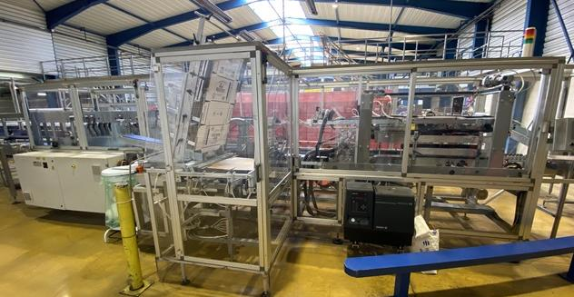

October 28th 2026 Offer Nr 135.26.10.28.1

ATLANTA Giotto
Wrap-around packing machine
premium second hand

Brand manufacturer: ATLANTA
Type : Giotto
Year: 2015
Capacity: > 20 cartons per minute

Specs: wrap around case packer
entry on single lane
cartons 80 x H262 for 1.0L bottles
+ cartons 87,5 x H322 for 1.8L bottles

Technical detailed data: see pages 4 to 33

Layout of the equipment: see page 8

Packing: carton 4x3 bottles in format 1.5L PET
or carton 5x3 bottles in format 1L PET
in neutral or printed carton

Machine drive: Siemens S7 with touch screen panel
user-friendly HMI interface

Machine equipped with: infeed & outfeed conveyor
machine in exceptional good condition
now has been dismantled

Machine status: low working hours
was in production in a mineral water plant
in France till early 2025
now has been dismantled and recently
transferred to our warehouse

Machine location: Madregolo Collechio (PR) Italy

Available: immediately

